Nesting success and trends of White-tailed Tropicbirds Phaethon lepturus in the Seychelles and monitoring programme recommendations
April J. Burt^{1,2 *} Fernando Cagua^{1,3} Cheryl Sanchez ^{4,1} , Melinda Curran?⁵, Janske van de Crommenacker⁶, Arjan De Groene?⁷, Cousine person?⁸ Nancy Bunbury¹
¹Seychelles Islands Foundation, P.O. Box 853, Victoria, Mahé, Seychelles
²University of Oxford
³Centre for Integrative Ecology, School of Biological Sciences, University of Canterbury, Christchurch, New Zealand

³Nature Seychelles, Centre for Environment & Education, Roche Caiman, P.O. Box 1310, Mahé, Seychelles
⁴ Island Conservation Society
⁵Frigate Island Private
⁶ Green Islands Foundation
⁷Cousine Island Private
Abstract (~200 words)
In an effort to identify trends in breeding success and test the value of the data within a seabird hotspot region we combined monitoring efforts from six of the region's most vital nesting sites for tropicbirds. Tropicbird breeding success varied greatly between the sites. At Aldabra on average, for both species, 15% of nests were successful with most of the unsuccessful nests (70-75%) failing before hatching occurred. Breeding success was higher in the inner granitic islands and a lower proportion of nesting attempts fail at egg stage. On Aldabra, Aride and Cousin nest success rates for WT have been stable over the study period but the success rate for RT (Aldabra only) has changed markedly over time. At Aldabra the abundance of RT nests shows a negative trend and has been in constant decline since 2010. Contrastingly the abundance of WT nests has been stable and does not show any significant temporal trend. The Aride island WT population nest abundance showed a continuous negative trend since 2011. This study highlight that great amounts of data are being collected across the Seychelles, although there is some disparity between methods and that the data is not being fully utilised, at least not frequently enough, or at a high enough level to fulfil the true value of such data within a conservation management context. A streamlined monitoring framework is proposed.
Keywords: Seychelles, Tropicbirds, Management, Ecology, Feeding, Breeding
*Corresponding author.
Email address: aldabrascience@sif.sc (A. J. Burt).
1. Introduction
The Seychelles Islands are a hotspot for seabird biodiversity. The support the greatest abundance of tropical seabirds in the tropical Indian Ocean. with a total seabird population estimated at 2.2 million pairs across 14 species (le Corre et al.2012). It is also the main breeding ground in the Western Indian Ocean for several of those species, in particular the
White-tailed Tropicbird (Phaethon lepturus). It is estimated that 65% of the P. lepturus population nest in the Seychelles (le Corre et al.2012). Although P. lepturus are listed as ‘Least Concern’ on the IUCN redlist, their populations in the Western Indian Ocean are small (around 6,500 pairs; le Corre et al.2012) and the species is suspected to be in decline owing to predation by invasive species. Most islands in Seychelles now supporting breeding colonies are small, predator free or are very remote islands.

Breeding success in seabirds (measured as fledglings per breeding attempt) can be used as a measure of health/success of the species as well as provide an indication of overall health of the surrounding ecosystem/ocean (ref). Previous studies indicate that breeding success of colonial seabirds is mainly influenced by climatic variations (Ancona et al., 2011), food availability (Hamer et al., 1993; Dearborn et al., 2001), introduction of exotic species (Russel and Le Corre, 2009) and intra/interspecific competition (Coulson, 2001; Dobson and Madeiros, 2010). In the past, Seychellois seabird populations have been threatened by habitat loss, alien predators, and over utilisation as a food source; with expanding fishery activity and climate change also posing threats (Bristol, 2007). P. lepturus forages solitarily (Bailey 1968, Harrison et al. 1983) and it is rarely associated with flocks of surface feeding predatory fishes (Ashmole & Ashmole 1967, Au & Pitman 1986). They catch prey by surface plunging (Ashmole 1971) and exploit mainly the first few metres of the water column (Le Corre 1997), feeding on surface-dwelling prey, such as flying fish and squid (Schreiber & Clapp 1987). P. lepturus are ground nesting with a habitat preference of bare scratched patches inside rock or log cavities or next to vertical structures (Burger and Lawrence 2000).

Despite the importance of Seychelles as a breeding ground for P. lepturus and the threats presented by invasive predators, the status of the health of the population has not been evaluated at scales required for effective management. Here, for the first time, we compile and
report data from long term monitoring of breeding success for P. lepturus at the national level. We have two overarching objectives. First to determine major trends in breeding success that might indicate a decline in their populations, and to compare breeding success at a national. Secondly, we aim to investigate whether the monitoring programmes in place are adequate (i) to assess species health and determine factors influencing species success; and (ii) to ensure monitoring information feeds back into conservation management actions. We hope to streamline the monitoring programme across the Seychelles to ensure monitoring efforts fulfil research aims, allow direct comparability between sites and provide the framework to use data acquired in conservation management strategies within the region.

2. Material and methods

2.1. Study area
We engaged with all organisations/companies collecting tropicbird nesting success data within the Seychelles via the Seychelles Seabird Group. Data was available from six sites however this study includes four sites (two sites are mentioned in the discussion but data was insufficient to include in analysis); the sites vary in habitat type, area, management and breeding population (Table 1). Sites include:
2.1.1 Aldabra Atoll
Aldabra Atoll is approximately 1150km southwest of the main Seychelles island of Mahé (Figure 1), and consists of four islands of limestone formation. The islands are separated by several channels which have been carved by tidal movement in and out of the 365km² lagoon. Within the lagoon are a number of small islets. The two species of tropicbird nest predominantly on these islets and the monitoring takes place on islets in Passe Femme, south of Picard, and on the southern tip of Picard Island. The islets habitat consists of pitted limestone crevices and vegetation with varying degrees of coverage. The atoll was designated a Special Reserve in 1982 and was awarded UNESCO world heritage status in 1982.Aldabra has been managed by the parastatal organisation Seychelles Islands Foundation since 1981. The last assessment of breeding success was in 1980 (Prys-Jones et al.).
2.1.2 Aride Island
Aride is the northern-most granitic island of the Seychelles Archipelago (4.2000°S 55.6667° E). The island is situated 10 km away from Praslin and 50 km from the main island of Mahé (Figure 1). Aride has an area of 74 ha of which 5 ha are flat and 69 ha are mountainous with a maximum elevation of 134 m. WT Tropicbirds nest across the island but are monitored on the plateau along coastal and inland areas of forest, nesting in rock crevices, old coconut tree bases and amongst tree roots. The island became a Special Reserve in 1975 under Seychelles law and since 2004 has been managed by a local conservation organization, the Island Conservation Society (ICS). The last assessment of breeding success was 2005 (Ramos et al).
2.1.3 Cousin Island
Cousin is a low lying Island of 27 ha² (4.3314°S, 55.6631°E), 2 km off the coast of Praslin and consists of dense forest on the plateau and a hill of 69 m above sea level (Figure 1). The island has been restored from a coconut plantation back to native forest and WT Tropicbirds nest throughout this habitat but are predominantly monitored on the plateau both along the coast and inland. The nesting habitat is very similar to that found on Aride. Initially managed by the International Council for Bird Preservation, it is now owned by BirdLife International and managed by local NGO Nature Seychelles; the BirdLife country partner. The island has been protected since 1969 and was awarded the status of IUCN class 1A Special Reserve in 1975. The last assesment of breeding success was 1985 (Phillips).
2.1.4 Cousine Island
Cousine Island is a 26 ha² granitic island (4.3500°S, 55.6333°E). It is just over 1 km long, 400 m wide and 70 m at its highest point (Figure 1). The island is very close in proximity, size and habitat to Cousin Island. The WT Tropicbirds breed across the island but monitoring has concentrated around the accessible eastern side, with a variety of nest habitats being included. The island is privately owned and runs primarily as a conservation island but villas are present, which provides a necessary source of income to support conservation activities. The last assessment of breeding success was conducted in 2003 to 2005 (Malan et al, 2009)

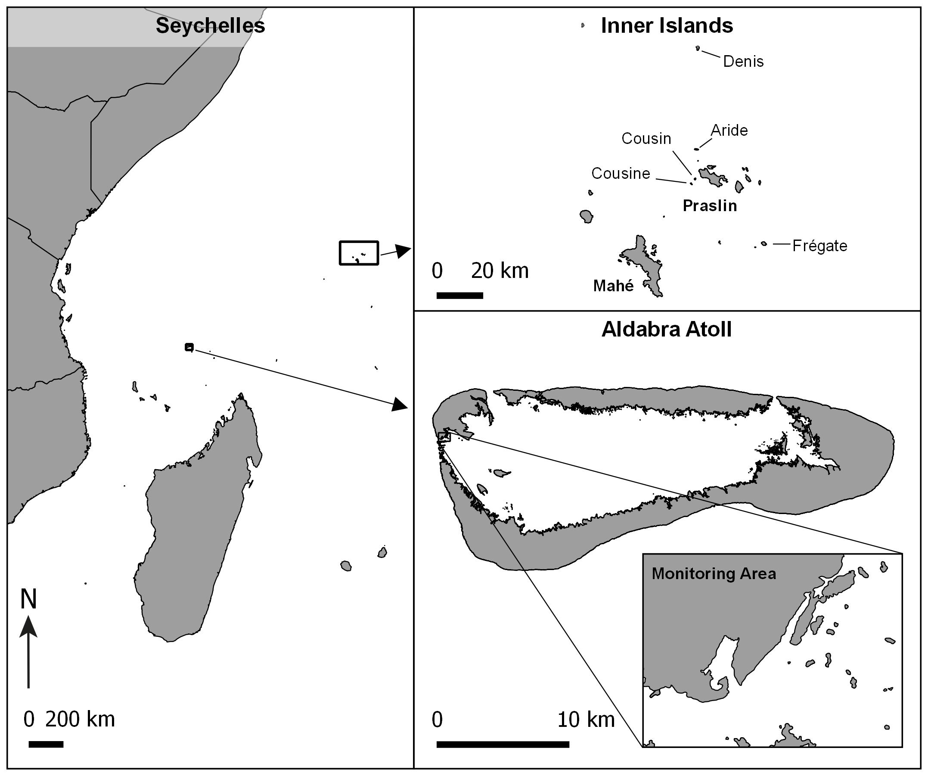
Figure 1: Map of Seychelles monitoring site locations

Table 1: Study site details
Site/Status | Methods | Population estimates/ Mean annual nests surveyed | Potential & recorded predators/disruptive species | Data available
Aldabra Atoll/ Special Reserve, UNESCO WHS | Continuous year-round monitoring of specific area. | 2000 pairs (Diamond 1971)/ 42 | Black Rat Rattus rattus, Grey Heron (Ardea cinerea), Aldabra Drongo (Dicrurus aldabranus). | 2009–2016
Cousin Island/ Special Reserve | Once or twice a year snapshot survey of approx. 100 nests. | 1,446 pairs (Burger and Lawrence,2000)/100 | Egg predators:  Seychelles skink (Trachylepis seychellensis), Wright’s  skink (T. wrightii) and Seychelles Fody (Foudia sechellarum)  (Malan et al. 2009). Adult mortality: Pisonia grandis | 2005–2007, 2009–2016
Aride Island/ Special Reserve | Continuous year-round monitoring of specific area. | 2110 pairs (Bowler et al. 2002)/170 | Egg predators:  Seychelles skink (Trachylepis seychellensis), Wright’s  skink (T. wrightii) and Seychelles Fody (Foudia sechellarum)  Until recently Big-headed ants (Pheidole megacephala), Ticks, Adult mortality: Pisonia grandis | 2011–2016
Cousine Island/ Privately Owned | Fixed nest sites monitored weekly | ??/107 | Egg predators: Seychelles skink (Trachylepis seychellensis), Wright’s  skink (T. wrightii) and Seychelles Fody (Foudia sechellarum)  (Malan et al. 2009). Adult mortality: Pisonia grandis | 2007–2011

2.2. Collection of data & Survey Effort

For all islands nesting tropicbirds were defined as an adult with an egg or a chick on a nest, though new nesting attempts were only added when the attempt was at the incubation stage. To determine whether a nest was successful of not, the stage at which it was last observed active was recorded. If a nest was observed to have been occupied by an egg or a partially feathered chick and it was subsequently observed empty or with signs of predation/death on the succeeding visit, it was assumed nesting was unsuccessful. If, conversely, a nest was observed to be occupied by a fully feathered chick and in the subsequent visit the nest was found to be empty and without signs of predation/death, it was assumed that nesting was successful and therefore fledgling was likely to have occurred (hereafter nesting success). For all islands the stage of failure was also recorded (whether at egg, downy chick, partially feathered chick or fully feathered chick stage).
The methods of sampling nesting attempts do vary between the islands and therefore impacted the depth to which analysis was possible. The methods for each island are as follows:
2.2.1 Aldabra Atoll
Monitoring of 13 islets and an outcrop of Picard Island have been monitored consistently every two weeks since 2009. This area is searched and all new nests are recorded and followed until failure of success is determined. Surveys were consistently performed between 6 February 2009 and 4 November 2016. During these trips a total of 333 nests were detected.
2.2.2 Aride Island
Aride island follows a similar sampling method to Aldabra whereby a specific area of the island has been monitored consistently from 2011 to present with all new nests within that area being included and monitored closely. Monitoring frequency is once per week. Surveys were consistently performed between 1 Jan 2011 and 31st Dec 2016. During these trips a total of 1033 nests were detected. The area surveyed is approximately XXXXha.
2.2.3 Cousin Island
Cousin Island has a long history of varying monitoring efforts but methods have been consistent since 2005 until present with just two years of missing data (2008 and 2012). The Cousin monitoring programme aims simply to establish an estimate of breeding success by sampling a certain number of nests (in most cases 100), not defined by area. Approximately 100 nests are selected when at the adult incubating egg stage and each attempt is followed until success or failure is determined, providing a snapshot of percentage breeding success.
2.2.4 Cousine Island
The methods used on Cousine Island are based on the monitoring of approximately 90 known nest sites continuously throughout the year. Therefore, data provides a monthly summary of new nests and nest outcomes and the amount of new nests could be used as a proxy for nesting population trends similarly to Aride and Aldabra.

2.3. Data analysis
The disparity in data collection methods disallows direct comparison analysis between sites, as well as a variation in the depth of analysis possible. For the purpose of this report we firstly look at mean nesting success at each site followed by constructing a series of GAMMs (Generalised Additive Mixed Models) with a binomial error structure to model the probability (i) of nesting abundance (ii) of nesting success, In these models we included date as a smooth term to investigate temporal trends (at Aldabra, Cousine and Aride). Competing models were assessed by comparing their Akaike information criterion (AICc)

3. Results
3.1. Overall Breeding Success
Average nesting success, expressed as a percentage of the total number of nests monitored, was lowest at Aldabra Atoll with an average 15.2% (SE +/-2.29) of nests were successful annually; most of the nests failing before the egg hatched (61% for RT and 66% for WT). On Cousin over a period of ten years annual nesting success averaged 33.20% (SE +/-4.04) and failure at egg stage was the outcome for an average of 48% (SE+/-5) of the nesting attempts (ranging from 24% to 73%), whereas failure at chick stage accounted for an average of 27% (SE+/-9) of nesting attempts. For Aride annual nesting success averaged 40.2% (SE+/-3.8) and for Cousine 51.6% (SE+/-2.9).
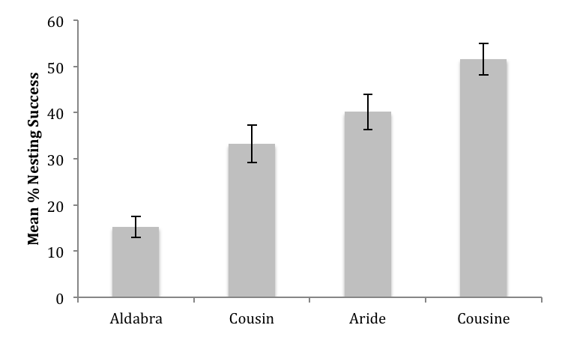
Figure 2: Mean annual nesting success including standard error bars. Note: Aldabra n=7, Cousin n=10, Aride n=6, Cousine n=5.

3.2 Trends in fledging success and number of nests established
When exploring the long-term trends, data from Aldabra, Aride and Cousine enabled analysis of trends in nesting abundance as well as nesting success. Results shown in Figure 3A represent a highly significant decline in number of nests established on Aride Island across the study period (P Value etc). Whilst Cousine island nesting abundance was relatively stable (P value etc) and Aldabra P. LEPTURUSs also show relative stability? (P value etc).
Based on GAMM models of success probability over time both Cousine and Aride show non-significant declines (P values etc) whilst Aldabra shows a significant negative trend? (P values etc).
For Cousin the trends analysis using GAMM was not possible, however using a simple linear regression of nesting success over time there were no significant trends apparent ( F=4.16, df=8, P=0.07).

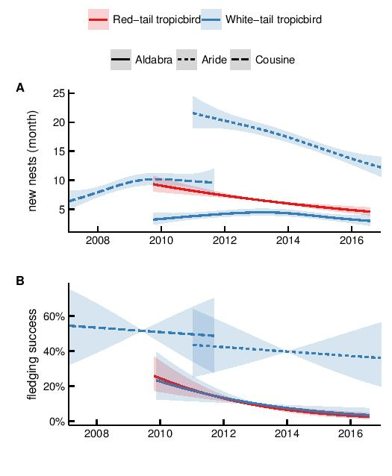
Figure 3: A) Number of new nests established by P. rubricauda (red) and P. lepturus (blue) annually. The shaded areas indicate the corresponding standard error. B) Probability of fledging success for P. rubricauda (red) and P. lepturus (blue) annually. Note: Only data from Aldabra, Aride and Cousine used due to suitability of data

4. Discussion
Breeding success monitoring
In an effort to identify trends in nesting abundance and success and to test the value of the data within a seabird hotspot region we combined monitoring efforts from the four most vital nesting sites for tropicbirds in the Seychelles. Tropicbird nesting success varied greatly between the sites, the lowest was recorded at Aldabra atoll, the most isolated site. Indeed, Aldabra has one of the lowest records of breeding success throughout their ranges though similar to that found at Fernando de Noronha archipelago where 14.3% of nesting attempts are successful and predation at egg stage account for 50% of the attempts. Europa supports even lower nesting success with 6.9% for non-rat controlled habitats (Ringler, Russell, and Le Corre 2015). Elsewhere breeding success is more aligned with that found in the inner granitic Seychelles; 30% in Ascension Island (Stonehouse 1962), 21% Cayo Luis Peia, Puerto Rico (Schaffner 1991).
The trends in nesting success which are shown within this study are reinforced when comparing to the earlier studies conducted; on Cousine 51.6% nesting success was recorded compared to 25% by Malan (2005); Cousin averaged 33% in this study compared to the 36% recorded by Phillips in 1985, Aride averaging 40.2% compared to the 21-37% recorded by Ramos et al. in 2005. The Aldabra population has shown a decline in nesting success within this study as well as compared to previous studies, with an annual mean of 15% compared to 47.5% recorded by Diamond (1975) and 46% recorded by Prys-Jones (1980).
Sites that are within reasonably geographical proximity (for example between Aride, Cousin and Cousine) may be expected to be under similar influence of external factors such as climatic variations and food availability, as well as common natural predators. Aldabra on the other hand may be considered isolated from those by its 1000km separation. Indeed common natural predators and similar habitats on Aride, Cousin and Cousine include the lack of invasive rats, similar habitat type (pers. Obs, April J Burt) , natural predation by two endemic skink species and ghost crabs. Additionally, on Cousine island, Malan et al. (2003) also observed egg predation from the Seychelles Fody, whilst Ramos et al (2005) described the impact of hard ticks on nesting success of WTTB on Aride Island. More recently invasive big-headed ants have been observed infesting WTTB on Aride (pers.obs, Melinda Curran). For Aldabra, Diamond (1975) stated that failures occurred due to intraspecific competition over nest sites, and possible impacts of the large Birgus latro crabs (largest land arthropod) with no mention of the invasive predator Rattus rattus. Recent camera trap efforts showed that the endemic Drongo was a predator of chicks and that rats and grey heron may also predate WTTB nests though evidence was inconclusive. No adult Birgus latro crabs have been observed interacting with WTTB nests. The impact of rats on seabird nesting success has been widely documented (refs) though determining whether they are the main factor in the low nesting success and whether they are responsible for a declining trend on Aldabra is not possible within this study.

The Aride island WTTB population nesting abundance shows a continuous negative trend since 2011 whereas Aldabra and Cousine remained fairly stable. This decline on Aride was previously reported; Bowler et al. (2002) showed that the WTTB on Aride suffered an apparent decline of 60% between 1989 and 1998, and this report supports the continuation of this decline. Although the main causes for this decrease was not identified at the time, additional work by Catry et al (2009) determined that annual adult survival could not be linked to inter-annual variability in oceanographic conditions, but may be more influenced by Pisonia fruiting events, which, overall, accounts for 23.2% of the adult mortality (Pisonia grandis produces sticky seeds which trap and kill seabirds). Based on survival rates they predicted that the probability of extinction of this population would be 99% in 170 years and suggested some active management by maintaining some open areas both at canopy and ground level. Despite Ramos et al. (2005) finding that breeding success for WT on Aride was significantly correlated with the El Nin˜o Multivariate Index there was little evidence that productivity was influenced by local factors in general. There are two key factors that suggest population decline on Aride is caused by adult survival at the site; firstly that Aride island continues to maintain relatively high and stable breeding success for WTTB and secondly that neighbouring island Cousin maintains stable population trends (1987 to 2014, unpublished data) indicating that adult survival is not linked with external factors.

Monitoring Programmes
The Republic of Seychelles was recently named one of five small island nations declared world leaders in conserving threatened species (Rodrigues et al. 2014) and there is widespread emphasis throughout the Seychelles in collecting valuable data for use in conservation management. Monitoring programmes are conducted not just by NGOs and parastatal conservation organisations but also on private islands where there is now a precedent for having a conservation staff/team. These efforts are not to be under-estimated and should be encouraged, however it is important to ensure that the effort put in is justified by the value of the data. A clear understanding of how the information derived from the monitoring may help to conserve the species is required. Reynolds et al. (2016) outline a roadmap for designing and implementing biological monitoring programmes, which is a useful reference in this instance to ensure the programme has value going forward. Specifically, a clear motivating problem should be framed with explicit objectives, followed by programme design and implementation with an adaptive stage to ensure assessment of data and methods, results and actions. For us the motivation is both to guage the status of an important seabird species and to use this species as an indicator of ocean health, the objectives are to monitor nesting success trends and if a negative trend is observed, to understand the cause. A nationwide monitoring plan should be implemented with just consideration for the spectrum of resources available at each site. The following recommendations are made:
- A basic monitoring programme should consist of year round monitoring of a designated area (with consideration for accessibility for regular monitoring and representative of typical nesting habitat) that is large enough to include a sample size of minimum 30 nests per year. This area should then be monitored closely with sustained continuous effort to ensure all new nests are recorded and followed until breeding outcome is determined. This method allows for a multi-parameter monitoring programme, including overall nesting success but also seasonal and temporal nesting success and nest abundance to be recorded. The basic monitoring should record stage at failure.
- Monitoring should be conducted a minimum of once every two weeks (though ideally more frequently) to ensure: a) that the number of new nests which fail in early stages are captured as much as possible and b) to endeavour to correctly record the stage at which nesting failed.
- Additional parameters may be included that do not enhance time or personnel required though add some complexity to the monitoring programme (and therefore must be explicitly described in a methods protocol). These may include: 1) a measure of nest site choice. Nest site is an important factor governing nest success, avoiding excessive cold and hot temperatures are essential for egg development stage as these can slow development and cause embryonic death (Grant 1982; Olson et al. 2006) and tropical seabird species have a more delayed onset of thermoregulatory capabilities when compared with those in temperate environments; therefore nest microhabitats and behavioural thermoregulation, are important factors during egg brooding and early chick development (Hart et al, 2017). Indeed, nest site choice could therefore negate some effects of environmental stressors with some habitats providing suitable nest microclimates (Hart et al, 2016). Nest site choice can be recorded in terms of habitat type (e.g vegetation/rock crevice/tree limb etc) and site exposure (e.g level of shade, peripheral cover from weather, accessibility to predators etc). 2) Evidence or observation of predator interaction.
- Any additional programmes that monitor the ecosystem that WTTBs interact with are beneficial and may be useful in determining or ruling out certain factors affecting nesting success. For example monitoring trends in natural or invasive predators, vegetation phenology and climate variables.
- Should a declining trend in nesting success be observed then further actions may be taken to determine cause, these may include the use of camera traps on nests to observe factors such as predation, chick feeding frequency and nest desertion by adult. If there is no obvious cause then further investigation of external factors such as climate, food availability may be investigated via satellite data coupled with geo-tagging birds.
- To enable national level monitoring of WTTB a standardised protocol should be developed and followed at all sites coupled with a standard database format to ensure data management enables and leads to relatively frequent analysis which can provide site managers with the information to make appropriate and informed management responses.

5. Conclusions

The Western Indian Ocean has recently been identified as a key area to prioritize for the conservation of global marine biodiversity in the face of climate change (Ramírez et al. 2017). The Seychelles Archipelago supports the greatest abundance of seabirds in the tropical Indian
Ocean with 14 breeding species totaling 2.2 million pairs (Le Corre et al, 2012). Regional seabird population success and trend data is not readily available despite data being collected for many years at several locations. A greater effort must be made to streamline regional data and utilise the results to steer management practices and channel research resources towards the most critical areas.

